Virtusa React Training

B Sahil (221910304005)

Day 11

Que1. Create a class component called with your name, in that the name of the state is ‘display’ and if the display is true it needs to call the class component or else it needs to display your surname.

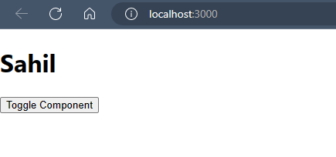

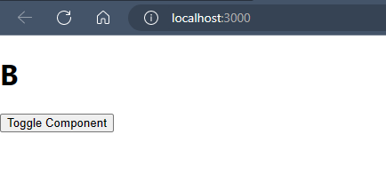

App.js

import React from "react";

import Sahil1 from "./Sahil1";

class App extends React.Component

{

constructor()

{

super();

this.state={

display:true

}

}

render()

{

return(

<div className="App">

{

this.state.display?<Sahil1/>:<h1>Sahil</h1>

}

<button onClick={()=>this.setState({display:!this.state.display})}>Toggle Component</button>

</div>

)

}

}

export default App;

Sahil1.js

import React from'react'

class Sahil1 extends React.Component

{

componentWillMount()

{

console.warn("Component will mount called")

}

render()

{

return (

<div className="App">

<h1>B</h1>

</div>)

}

}

export default Sahil1;